**Rohith Rajagopalan Ramesh Babu**

**1001518031**

[**2208-CSE-5382-001**](https://uta.instructure.com/courses/62497)

**Assignment-1**

**Task-1:**

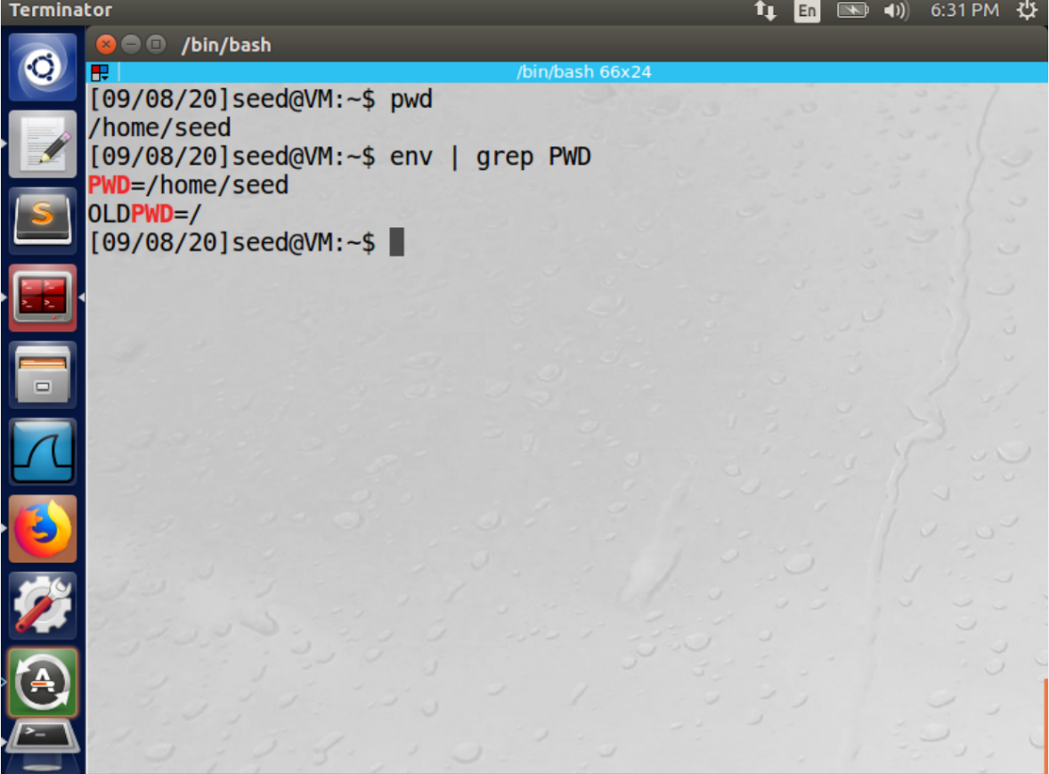

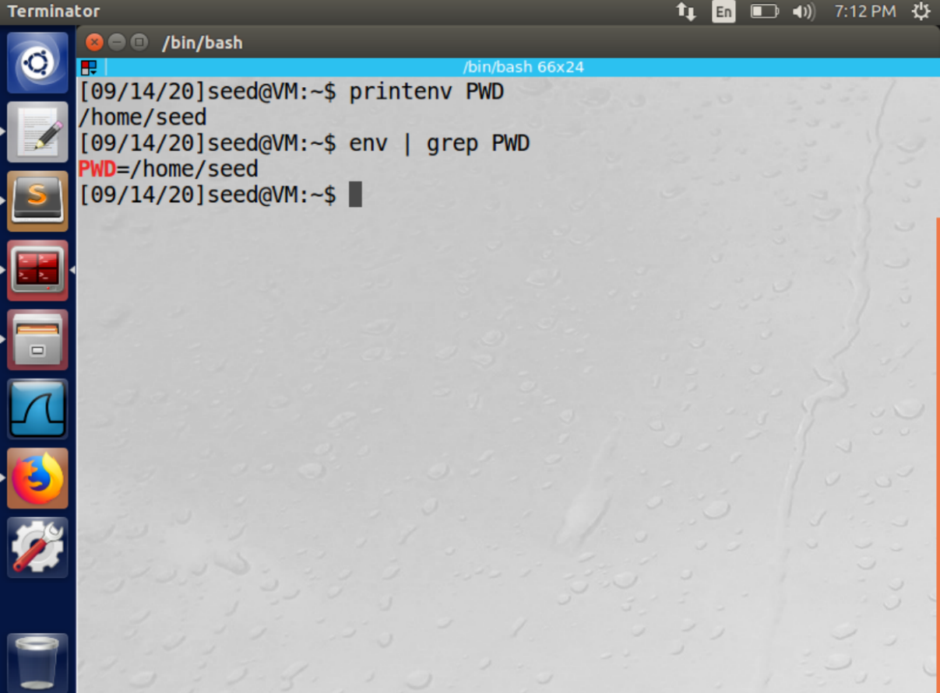

**Observation:** From the screenshot we can see that the given instructions were executed, and the output is displayed

**Task-2:**

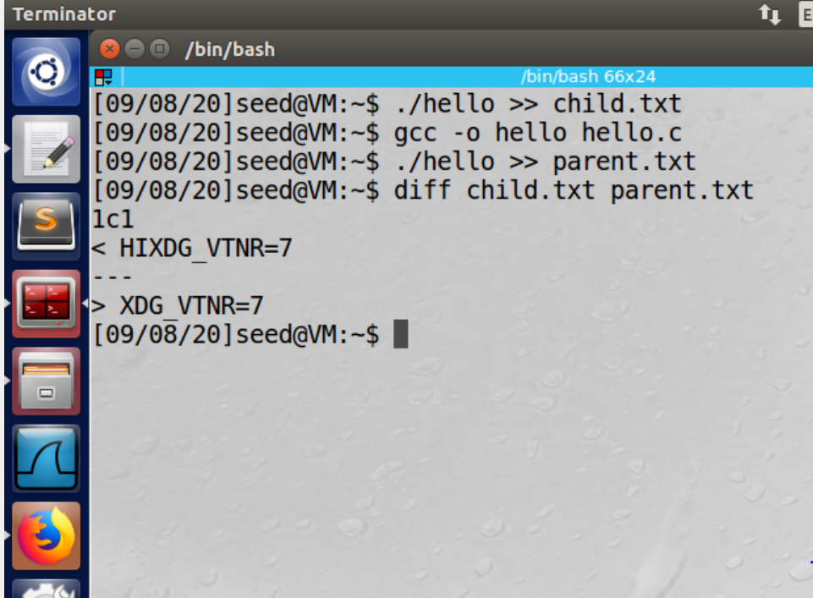

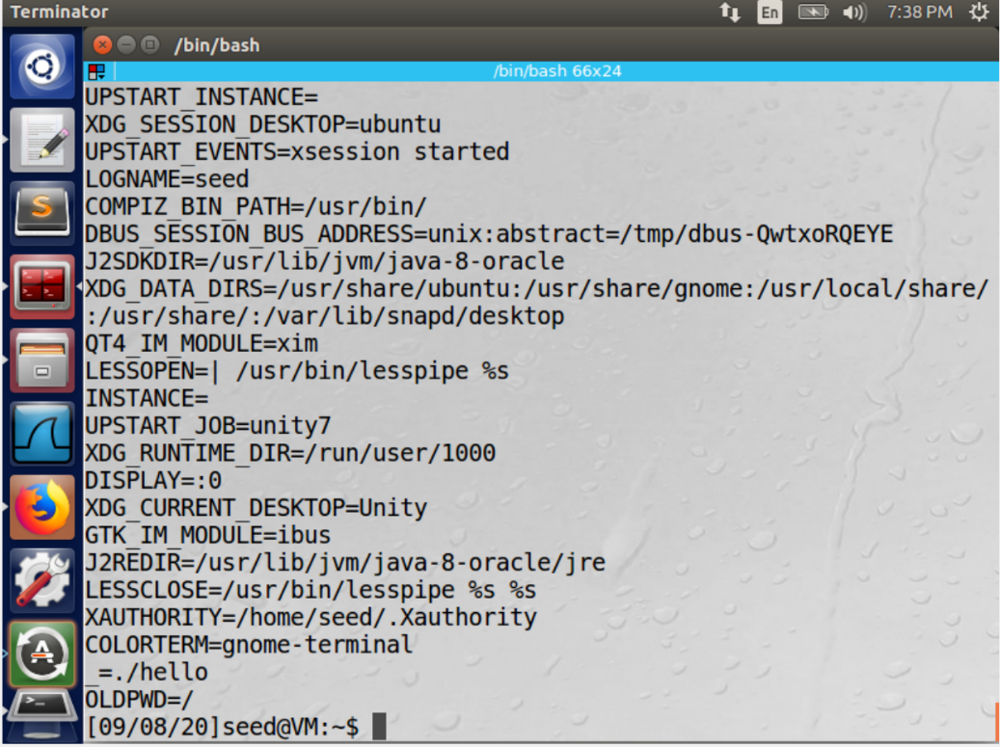

**Observation:** We can infer that the child process and the parent process are the same. Two processes can execute concurrently as Unix is a time-shared OS.

**Task-3:**

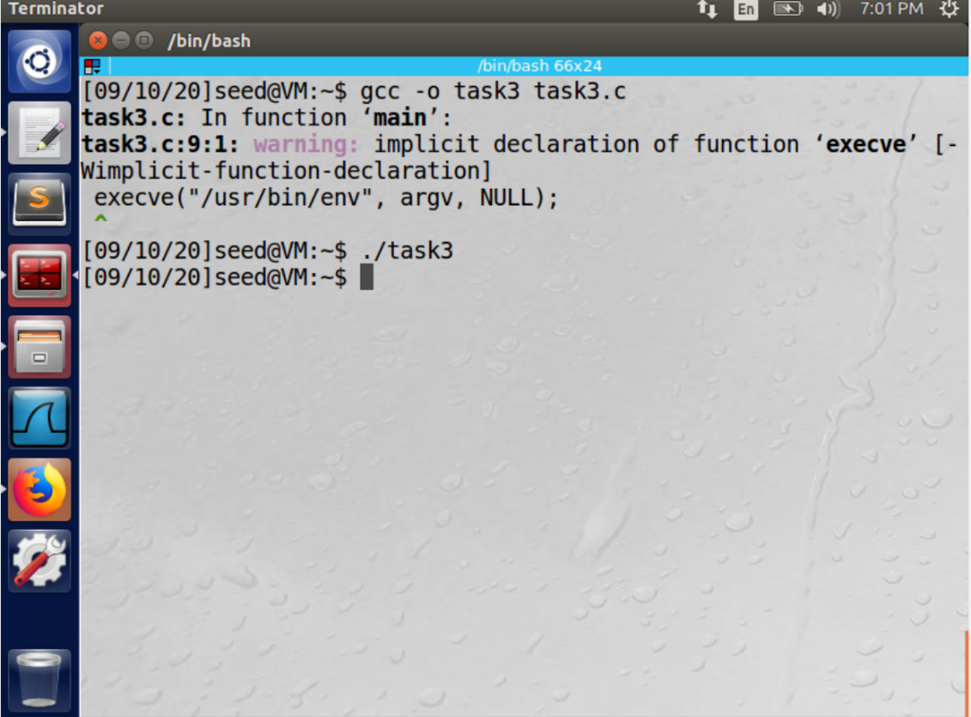

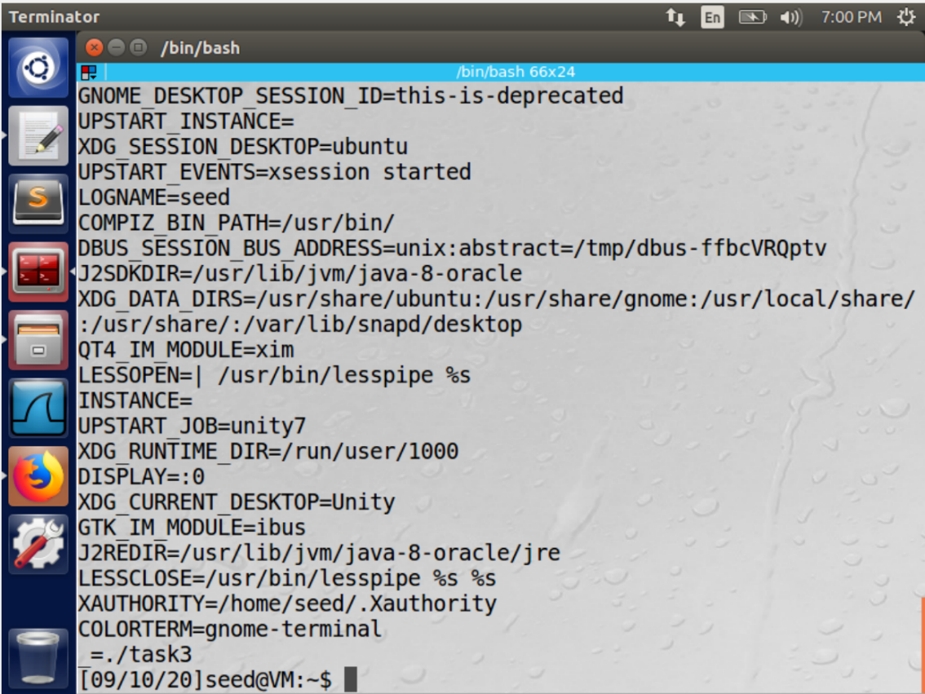

**Observation:**

* Passing “NULL” as the third argument we just get the set of commands executed(No Output)
* Passing “ENVIRON” as the third argument displays the environment variables

**Task-4:**

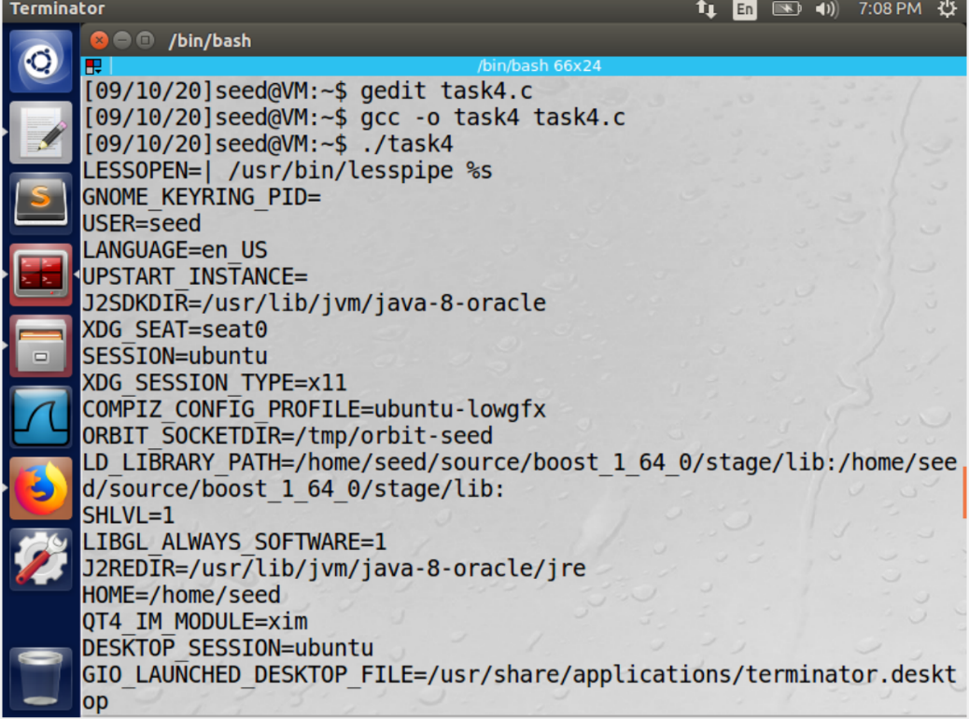

**Observation:** The observation obtained here is that the environment variables are displayed when the program is executed

**Task-5:**

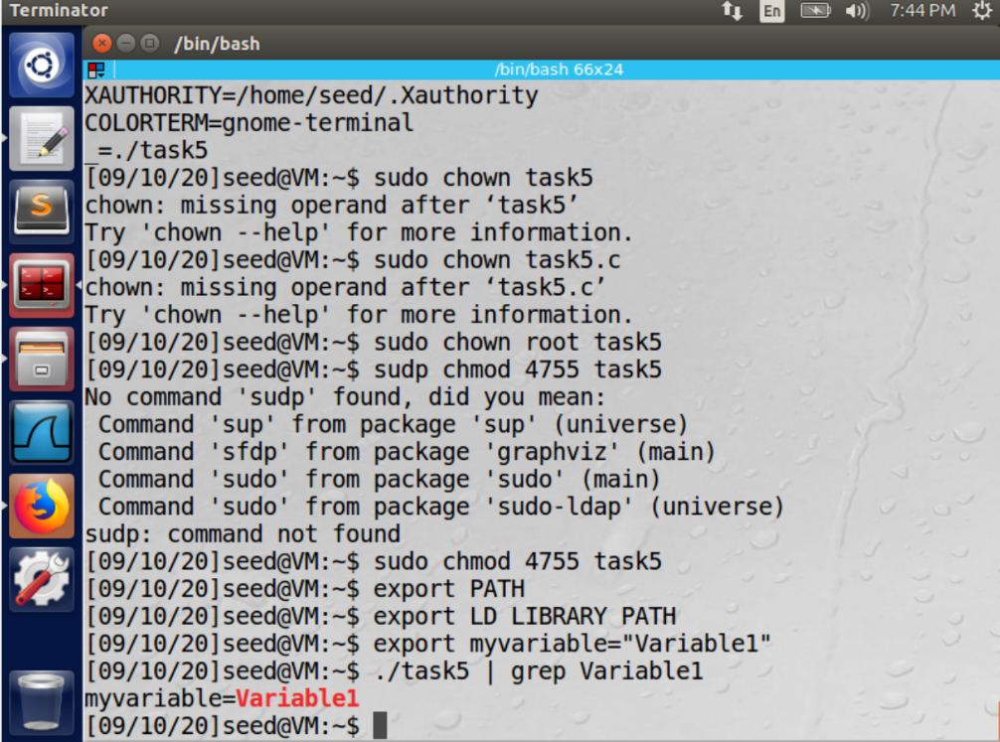

**Observation:**

* The exported Variable “Variable1” is seen when the set of instructions are executed.
* The environment we set in the parent process enters the child UID set process

**Task-6:**

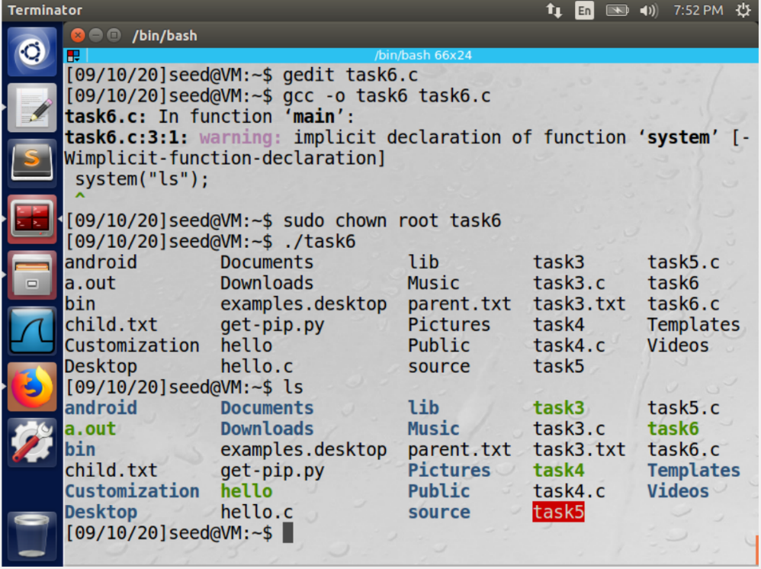

**Observation:**

* By enabling the root privileges, we can execute the code to perform the ‘ls’ command
* we can run the set uid program instead of /bin/ls but this method is not adviced as Set-UID is root based and has its own set of privileges on the other hand /bin/ls lists all the processes directly from the system.

**Task-7:**

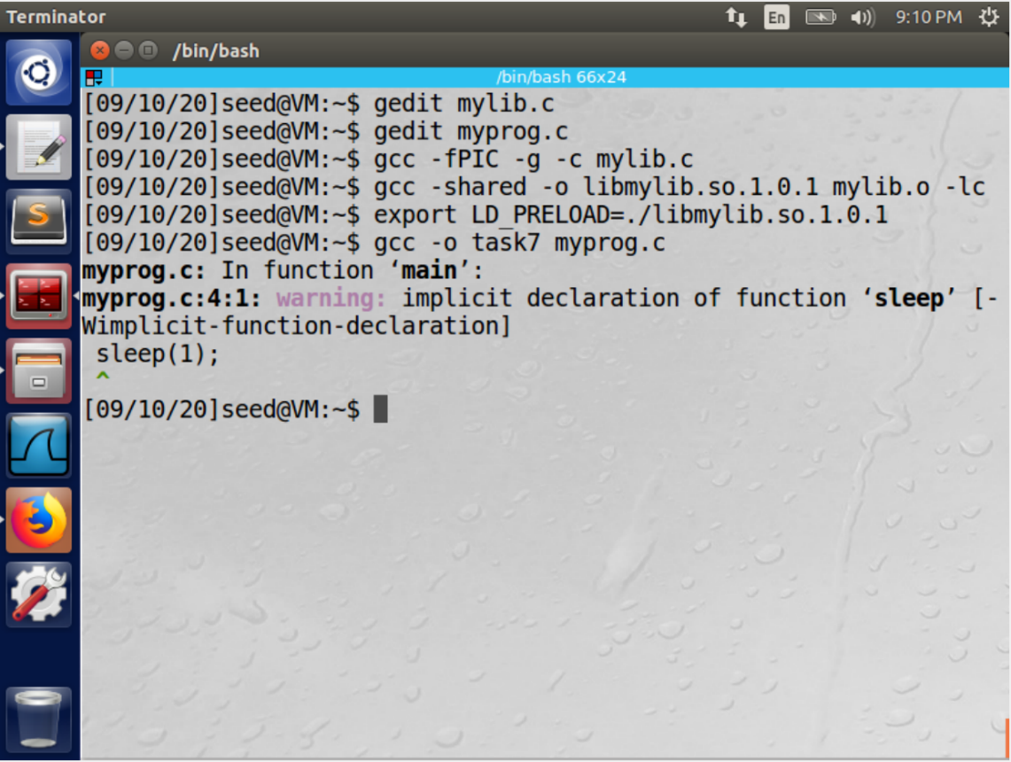

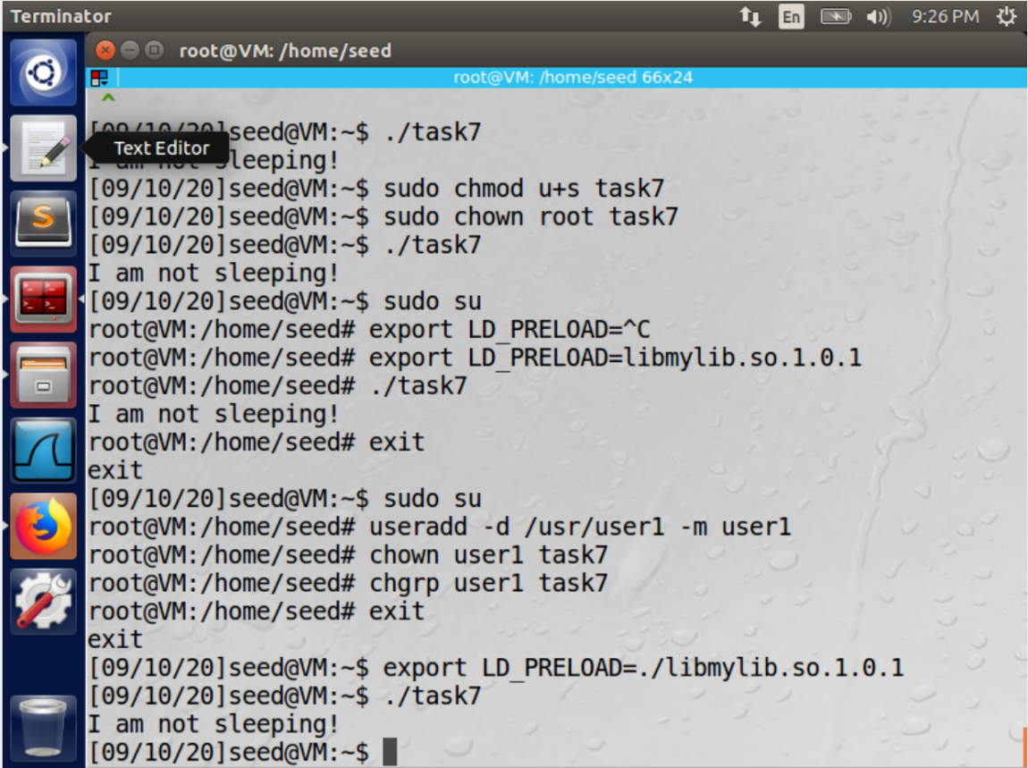

**Observation:**

* The Output for the given set of instructions is as shown.
* Myprogram executed in different scenarios gives the same output
* The child process may not inherit the LD * environment variables

**Task-8:**

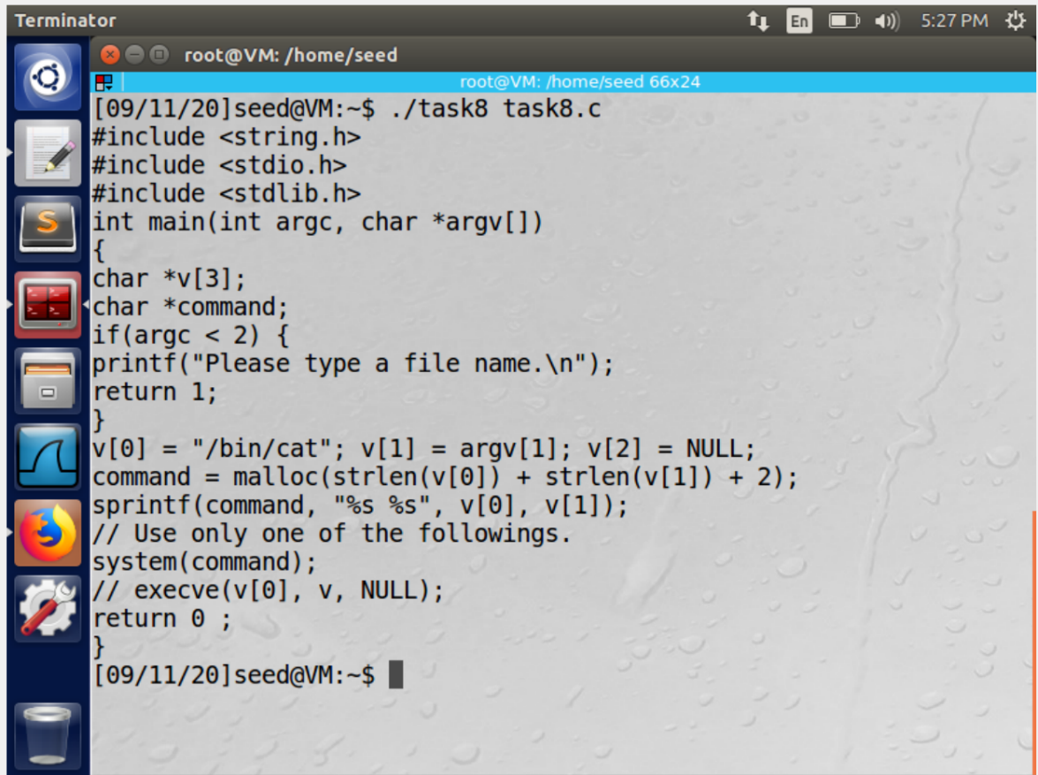

**Observation:** we observe that we get access to the file when the code is executed using the system() command, but we do not get access while using the execve() command

**Task-9:**

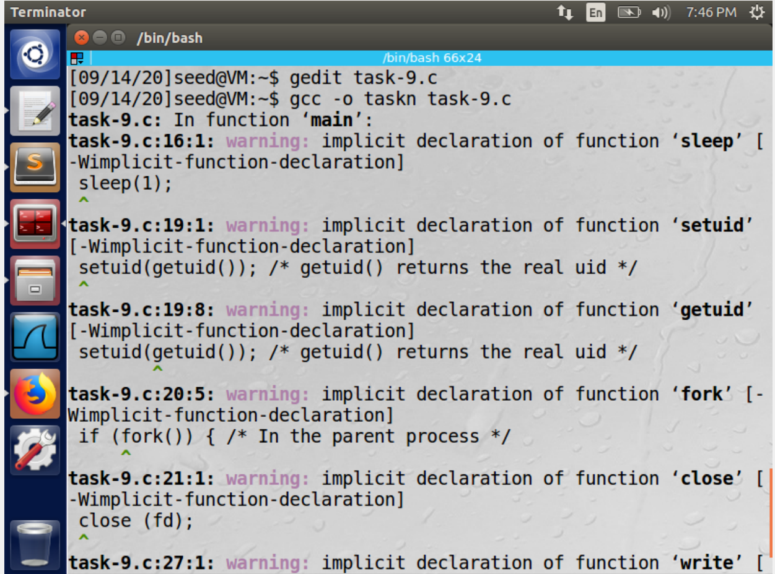

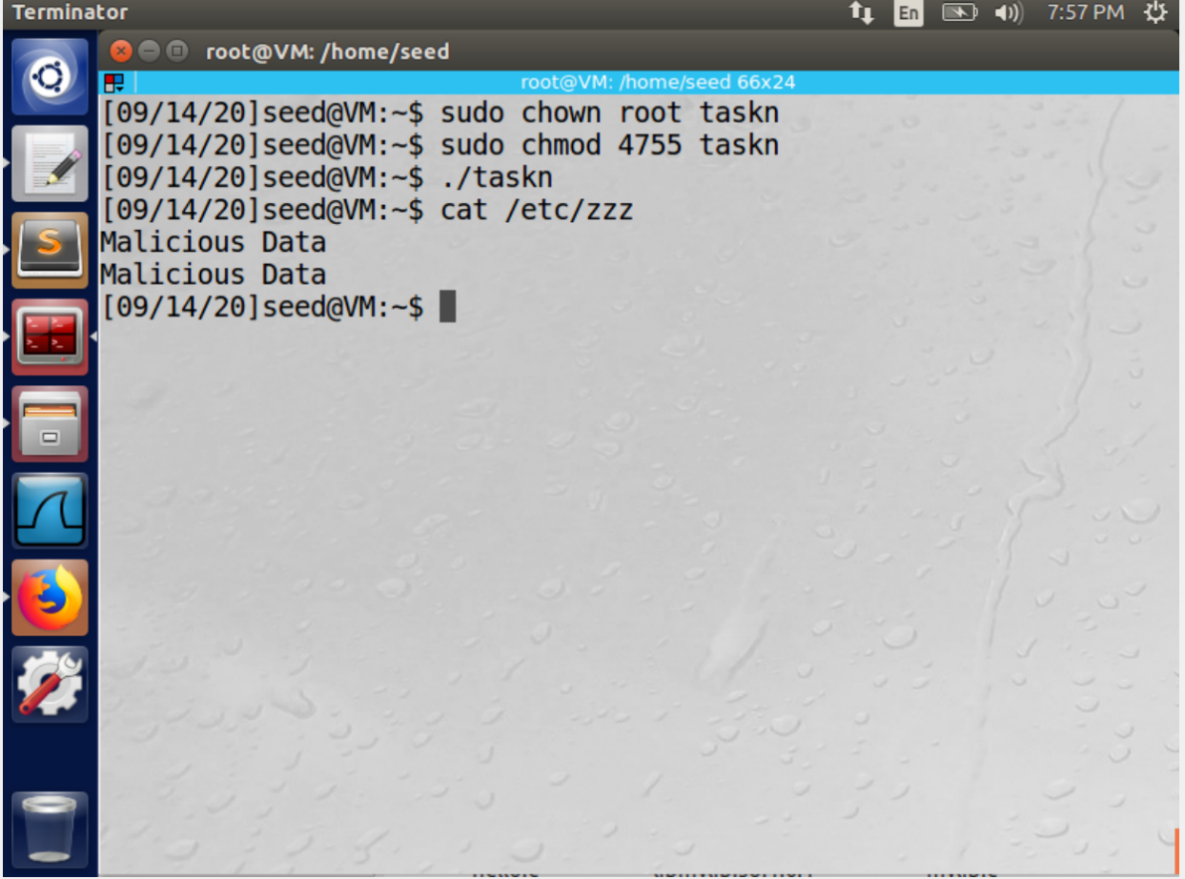

**Observation:** The file zzz is not accessible unless it is owned by the root and is set to a SETUID program. Once these two steps are performed then the file is accessible